Machine Learning et Data Analytics – Project no. 1

Convolutional neural networks in classification of faces

Krzysztof Madajczak 29.10.2023r.

**Entry:**

The project's main objective was to create a neural network capable of accurately identifying human faces in images. To achieve this, the subject of the project focused on the implementation and analysis of a convolutional neural network (CNN) for classifying human faces based on images. This CNN was developed and evaluated with the aim of comparing its effectiveness with alternative approaches, including different neural network architectures and transfer learning solutions.

The project began with supervised learning, utilizing a carefully chosen XYZ training dataset that featured close-up images of faces. The primary task for the model was to classify the emotions depicted in these images into two distinct classes: 'face' or 'no face.' This comprehensive analysis and implementation allowed for the evaluation of the CNN's performance and its ability to accurately discern human faces in images.

**Data:**

The training process involved a dataset comprising 64,770 facial images, 26,950 non-representational images, all of which were in a format of 36x36 pixels with a single colour channel (grayscale).

|  |  |
| --- | --- |
|  |  |

**Adam vs SDG + Learning Rate**

I conducted experiments in which I analysed the performance of various optimizers, particularly the **SGD** (Stochastic Gradient Descent) and **Adam** algorithms.

**SGD** is a gradient-based optimization algorithm that involves updating weights in the direction opposite to the gradient of the loss function with a small step size. On the other hand, **Adam** (Adaptive Moment Estimation) is a more advanced algorithm that combines elements of momentum and gradient scaling, allowing for dynamic adjustment of the learning rate during training. Unlike SGD, Adam also takes into account first and second-order moments, making it more effective for complex and irregular loss functions.

|  |
| --- |
|  |
|  |

* Two methods have the same settings, the only difference is the optimizer

In Our Case Adam performed better that could be, because face image are more complex and because of that Adam have better algorithm which updates the weights of the model.

As we can see SDG works better with higher Learning rate and Adam is not as volatile

**Imbalanced Dataset - Weighted Cross Entropy**

Our dataset is imbalanced, with three times as many photos of faces as there are of no faces. This creates an issue because during training, our model would automatically bias towards face prediction.

To address this problem, there are a couple of approaches we can take. We can either acquire more pictures that represent the missing class, or we can adjust the weight during the learning process. I test updating the weights.

|  |  |
| --- | --- |
| **Without** Weight Scaling | **With** Weight Scaling |

nn.CrossEntropyLoss(weight=torch.tensor([3.0, 1.0]).to(device=self.device),  reduction='mean')

As we can see in the example, weight scaling improves our model's performance by 10 percentage points.

**Architecture NN**

Architecture of our network in key part during this project. The default architectural presented in the project is not complex and because it is missing several layers, it ability to detect faces is limited.

I experimented with my own network 4 convolutional layers with leaky relu or relu activation form.

|  |  |
| --- | --- |
| Default network | Main network |
| **Convolutional Layer:** The first convolutional layer with 1 input and 6 outputs, with a 5x5 kernel.  The second convolutional layer with 6 inputs and 16 outputs, with a 5x5 kernel.  **Pooling Layer (Max Pooling):**  Max Pooling is applied after both convolutional layers with a window size of 2x2.  **Fully Connected Layers:**  The first FC layer has 16 * 6 * 6 inputs and 32 outputs.  The second FC layer has 32 inputs and 16 outputs.  The third FC layer has 16 inputs and 2 outputs, suggesting two possible output classes. | **Convolutional Layers:**  The first convolutional layer with 1 input and 8 outputs, with a 5x5 kernel.  The second convolutional layer with 8 inputs and 16 outputs, with a 3x3 kernel.  The third convolutional layer with 16 inputs and 32 outputs, with a 3x3 kernel.  The fourth convolutional layer with 32 inputs and 64 outputs, with a 3x3 kernel.  **Batch Normalization Layers:**  Batch Normalization layers are used after each convolutional layer to improve stability and accelerate learning.  **Activation Functions:**  The CNN_NET can use both ReLU and LeakyReLU activation functions depending on the value of the activation variable.  **Max Pooling Layers:**  Max Pooling is applied after the second, third, and fourth convolutional layers.  **Fully Connected Layers:**  The CNN_NET has three FC layers:  The first FC layer has 576 inputs and 256 outputs.  The second FC layer has 256 inputs and 128 outputs. The third FC layer has 128 inputs and 2 outputs |

To calculate layers I used:  
https://madebyollin.github.io/convnet-calculator/ - calculor for AI

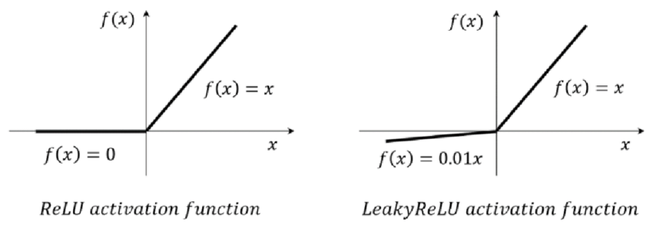

ReLU (Rectified Linear Unit) is an activation function used in neural networks that activates only when the input signal is greater than zero, effectively stopping at zero otherwise. Leaky ReLU is a similar activation function, but it allows a small gradient to flow for x < 0, helping to mitigate the vanishing gradient problem.

**Early Stopping**

Early Stopping is a regularization technique in neural network training that involves monitoring the model's performance on validation data and stopping training when its performance on these data starts to deteriorate to prevent overfitting. The best model achieved during training is saved, and after training is completed, it's advisable to test it on test data to assess its generalization. This is an effective way to obtain a model with good generalization capability and avoid overfitting to the training data.

In my project we define the patience parameter which represents how many epochs in a row the model will continue before stopping.

**Implementation:**

Every epoch we check the performance and we overwrite when the model achieves better performance

|  |
| --- |
|  |

**Data Augmentation**

Data Augmentation is a technique I use in machine learning. It involves generating new training samples by introducing various modifications to input data. In my case, I employ techniques such as randomly reducing the number of horizontal levels (RandomPosterize), flipping images horizontally and vertically with certain probabilities (RandomHorizontalFlip and RandomVerticalFlip), random histogram equalization (RandomEqualize), and color inversion (RandomInvert) with specified probabilities. Additionally, I apply techniques like random affine transformations with options for rotation, translation, and shearing (RandomAffine), Gaussian blur (GaussianBlur), and adjustments to brightness, contrast, saturation, and hue (ColorJitter) with designated probabilities. All of these methods help me create diverse training data variations and enhance the performance of my machine learning model.

|  |
| --- |
|  |

**Detecting the multiple faces on the picture**

**Selective Search:**

**Sliding Window:**

**Single-Shot Multiple box Detector:**

**Data:**

Things to do:

1. SGD/ADAM
2. Learning rate (10^-5 , 10^-3)
3. Imbalanced Dataset, Weighted Cross Entropy
4. Architecture NN
5. Early Stopping
6. Data Augmentation

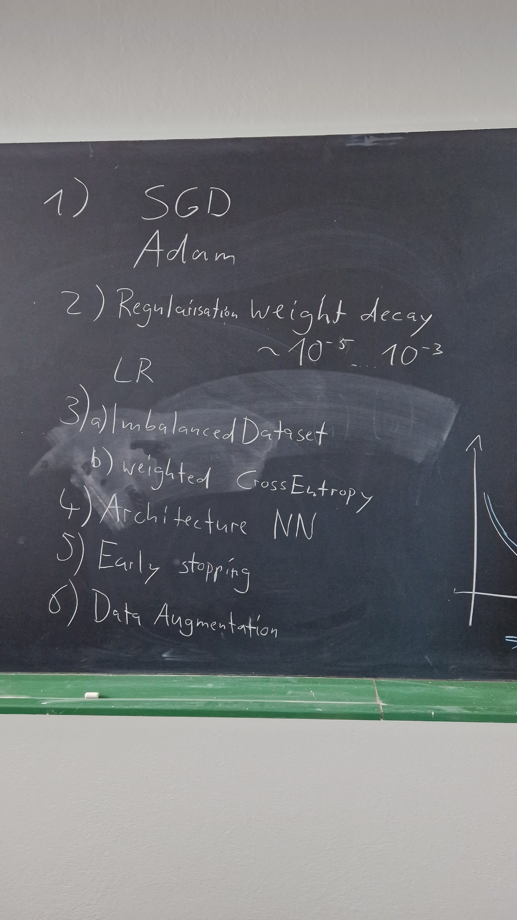

Optimalization the hyper-parameters

* Library
* Inhaling
* Etc

Use pre-train model ex. **Resnet-18**

Use previous wights to continue learning without analyzations the image from scratch.

**Sliding windows detection**

**Single-Shot Multiple box Detector** **(SSD)**

Region Proposals

* Selective Search
* R-CNN
* YOLO
* SegNet
* J-Net

